**ICTPRG532 Apply advanced object-oriented language skills**

AT2: Networked Math Quiz (Java) – complete and provide with your assignment submission

Student Name: Kaue Macruz

Student Number: 465063477

1. Present an outline of your procedure in developing this project. The outline can be a broadly defined set of tasks which you have planned and completed. Your outline must show a breakdown of development, including testing and debugging.

* Requirements:

Here all requirements are gathered and analysed. For this project all requirements were provided by the teacher.

* Design:

In this phase logical and physical design are done. The logical is when possible solutions are

brainstormed and theorized. The physical is when the logical design is completed and ready to

be concreted.

For this project the design was specified and given to the programmer.

* Implementation:

In this phase coding is done. Programmers assimilate the requirements and specifications from

the previous phases and start programming the actual project.

Development Breakdown

* GUI

Here is where the design with frames, fields, buttons, etc is created

Teacher GUI:

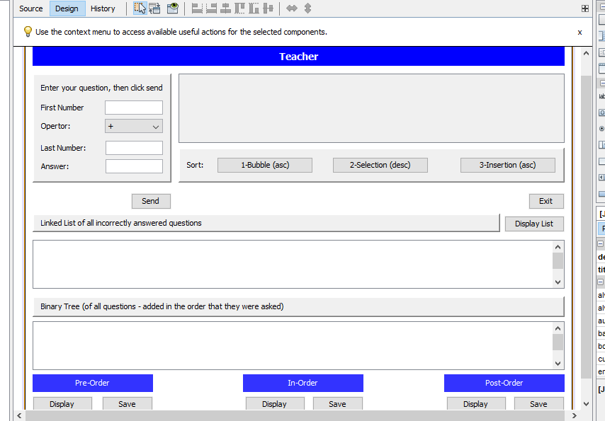

Student GUI:

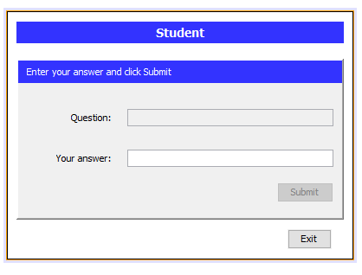

* Networking/Sockets

Networking is the first thing to be done for this application to work. Before any implementation of methods and new classes, both classes here (Student and Teacher) should be able to communicate with each other.

* Methods

Here all necessary functions to the program to work are implemented.

* Classes

In order to get all functions to work a few classes are needed:

BinaryTree<T> - Class created to store data in a Binary Tree structure

Node<T> - Supports the BinaryTree class comparing values

Question - Created to store and compare data in an ArrayList

* Verification:

Here testing is done and customers review the achievements of the programmer to check if it

matches requirements and everything is properly working. Here it is also when the version control

happens. If customers are not satisfied or errors were found in the code, a new version must be

created.

Testing Breakdown:

|  |  |  |  |  |
| --- | --- | --- | --- | --- |
| Test Case ID | Use case description | Test plan | Results | Fixes |
| T001 | Run the application with both files (Student.java and Teacher.java) | 1. If Student.java is opened before Teacher.java a JOptionPane dialog indicates connection error  2. Teacher.java is opened then Student.java is opened, application runs with no errors    3. If Student.java is shut down (Exit button) a JOptionPane dialog indicates connection error  4. If Teacher.java is shut down (Exit button) a JOptionPane dialog indicates connection error | PASSED  PASSED  PASSED  PASSED |  |
| T002 | Sending question to Student | 1. Attempt to send question with blank or non-numeric values shows a JOptionPane dialog with the appropriate message  2. Once Send button is pressed and fields have numeric values, the answer field is filled with the right answer  3. Once Send button is pressed and fields have numeric values, Send button becomes disabled  4. Once Send button is pressed and fields have numeric values, Student gets the Question field filled with the question and Submit button is enabled  5. Once Send button is pressed and fields have numeric values, a new row with the question values and the answer appears in the JTable  6. Once Send button is pressed and fields have numeric values, the Binary Tree JTextArea shows the question and answer  7. Once Send button is pressed and fields have numeric values, if more than one question have been already asked, the Binary Tree JTextArea shows the questions and answers in the asked order | PASSED  PASSED  PASSED  PASSED  PASSED  PASSED  PASSED |  |
| T003 | Student answers question | 1. Once the submit button is pressed, the answer is correct or incorrect. A message box appears to the student showing the appropriate message (CORRECT or INCORRECT)  2. Once submit button is pressed it becomes disabled and question and answer field becomes blank again  3. Once submit button is pressed, a message appears in the LinkedLIst JTextArea in the Teacher site saying “Student answered correctly” or “Student answer incorrectly”  4. Once submit button is pressed, questions and answer field on teacher site goes blank and send button is enabled  5. Once submit button is pressed, if answer field has a blank or non-numeric value it shows a message box with the appropriate error | PASSED  PASSED  PASSED  PASSED  PASSED |  |
| T004 | Sorting JTable rows by answer values | 1. When Bubble sort button is pressed, JTable is bubble sorted in an ascendent order  2. When Selection sort button is pressed, JTable is selection sorted in an descendent order  3. When Insertion sort button is pressed JTable is insertion sorted in an ascendent order | PASSED  PASSED  PASSED |  |
| T005 | Linked List with incorrect answered questions | 1. When the Display List Button is pressed, the Linked List JTextArea shows all incorrect answered question in order they were answered where the HEAD is the first wrong answer and the TAIL the last | PASSED |  |
| T006 | Binary Tree with questions | 1. BinaryTree JTextArea displays all questions in order they were asked  2. When Pre-Order Display button is pressed, BinaryTree JTextArea displays all questions in Pre-Order  3. When In-Order Display button is pressed, BinaryTree JTextArea displays all questions in In-Order  4. When Post-Order Display button is pressed, BinaryTree JTextArea displays all questions in Post-Order  5. When Pre-Order Save button is pressed, a message box appears asking if you want to procedure, if no nothing happens, if yes a preorder.txt document is created (if not existent) in the same directory of the project with the content of the BinaryTree JTextArea  6. When In-Order Save button is pressed, a message box appears asking if you want to procedure, if no nothing happens, if yes a inorder.txt document is created (if not existent) in the same directory of the project with the content of the BinaryTree JTextArea  7. When Post-Order Save button is pressed, a message box appears asking if you want to procedure, if no nothing happens, if yes a postorder.txt document is created (if not existent) in the same directory of the project with the content of the BinaryTree JTextArea | PASSED  PASSED  PASSED  PASSED  PASSED  PASSED  PASSED |  |

Debugging:

Here we can see when the variable “question” is created in Watches

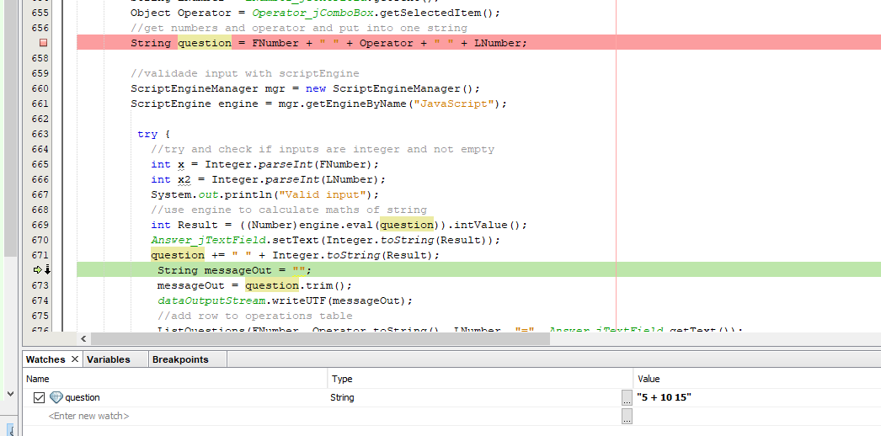

Here we can see all the variables used to create a single string variable “question”

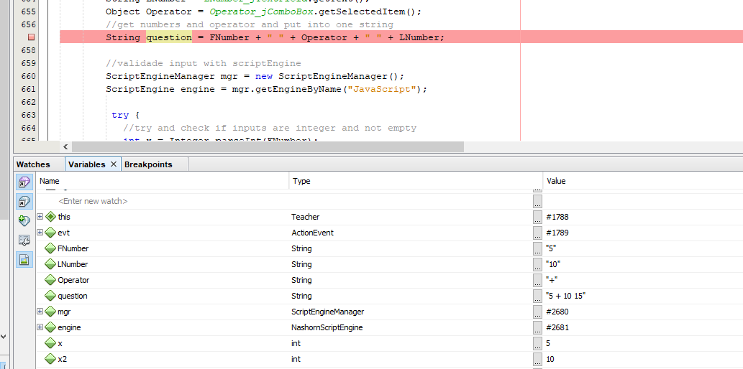

* Maintenance:

In this phase version control also happens since the customer is regularly using product

discovering bugs, inadequate features and other errors occurred during implementation. New

changes and versions are created and until the customer is satisfied.

2. Provide details of how you have managed version control during the development of this project

GitHub was chosen to be used for this project. It was chosen because it is free and has many

advantages over the other systems available. It stores file changes and ensures its integrity better.

Git is an open source version control system that manages and stores revision of projects. It is mostly

used for code but it can be used to manage any file type.

When a change is made, this change is made directly to the central repository.

GitHub is a Git repository hosting service, but it adds many features. It provides a web-based graphical interface. It also provides access control and several collaboration features.

3. Ongoing communication

3 (a) Email between you (as the developer) and your manager BEFORE commencement of the project to secure the project specification

TO: Hans Telford  
FROM: Kaue Macruz  
SUBJECT: Project Specifications

MESSAGE:

Dear Manager,

The purpose of this email is to clarify all requirements of the project and create a project

documentation for us to get started knowing that we all are heading to the same direction of the

project and its goals.

For my understanding I am required to provide a NetBeans project using the java programming language that successfully runs two (2) networked GUI (graphic user interface) desktop applications. The teacher application runs as the server and provides a student application (running as a separate client) an arbitrary number of simple math questions.

In this application it is required:

⦁ Implementation of a client-server architectural framework with data transfers

⦁ Implementation of an inter-process communication mechanism - Sockets (required for the networked communication)

⦁ Use of a dynamic array list (Java ArrayList class)

⦁ Use of a doubly linked list data structure (Java LinkedList class)

⦁ Use of a binary tree data structure (e.g. provided Java BinaryTree class)

⦁ Use of three (3) sorting algorithms (e.g. bubble-sort, selection-sort, insertion-sort) with comparisons

⦁ Use of class with a comparator interface (e.g. Comparable<T>)

⦁ Use of file writing to an external file for the purpose of saving data

I will be utilising the supporting documentation that you have provided me with designs and functionalities, please let me know if there is any requirement that I need to emphasize before commencing this project.

Looking forward to hearing from you,

Kaue Macruz

3 (b) Email between you (as the developer) and your manager regarding the proposed 3rd party library and licensing.

TO: Hans Telford  
FROM: Kaue Macruz  
SUBJECT: 3rd Party Library

MESSAGE:

Hello Hans,

For this project I am going to need a 3rd party library. I need to know if it is ok to purchase or download any 3rd party library needed for this project.

Thank you very much,

Kaue Macruz

3 (c) Email between you (as the developer) and your client regarding the proposed 3rd party library and licensing – include the benefits of the inclusion of the library in their project

TO: Hans Telford  
FROM: Kaue Macruz  
SUBJECT: 3rd party library

MESSAGE:

Hello Hans,

As I mentioned in the previous email, a 3rd party library will be needed for this project and I would like to utilise the Binary Tree library provided by you earlier in this project.

Please let me know if it is alright to use it and make any modifications if I need to.

By using this library it will save us money and time, since I will not need to create it from scratch and we both know that it flawlessly works.

Thanks again,

Kaue Macruz

3 (d) Closing email between you (as the developer) and your manager regarding the success of the project development. You need to include areas of concern or risk to your manager for inclusion in the development of the team’s risk matrix.

TO: Hans Telford  
FROM: Kaue Macruz  
SUBJECT: Closing report

MESSAGE:

Dear Hans,

The purpose of this email is to communicate that the project was successfully built with all requirements and tests achieved.

It is important to keep in mind that the application does have some issues and risks that need to be fixed and implemented for future versions of this application.

Here it is a list of possible risks we may encounter:

* Currently the application will only run in one machine. If it is needed to communicate with different machines new functions need to be implemented.
* No security has been implemented. It is advised that it would be safer to create profiles for students and teachers that way usernames and passwords can be used for the application.
* The application is pretty simple and straightforward, this application could have much more potential if new features were created for both teacher and student sites.

Please take these points into consideration and let me know if you are happy with the end result.

Looking forward to hearing from you,

Kaue Macruz